Assignment 1
M.K.H.S. Gujarati Girls College, Indore
Name : Aayushi Sethi
Class : BCA V sem
Subject : Computer Networks

Q.1. What is data Communication ?
Ans. Data communications refers to the transmission of this digital data between two or more computers and a computer network or data network is a telecommunications network that allows computers to exchange data. The physical connection between networked computing devices is established using either cable media or wireless media. The best-known computer network is the Internet.
In other words, Data communication refers to the exchange of data between a source and a receiver via form of transmission media such as a wire cable. Data communication is said to be local if communicating devices are in the same building or a similarly restricted geographical area.
The meanings of source and receiver are very simple. The device that transmits the data is known as source and the device that receives the transmitted data is known as receiver. Data communication aims at the transfer of data and maintenance of the data during the process but not the actual generation of the information at the source and receiver.
Datum mean the facts information statistics or the like derived by calculation or experimentation. The facts and information so gathered are processed in accordance with defined systems of procedure. Data can exist in a variety of forms such as numbers, text, bits and bytes.

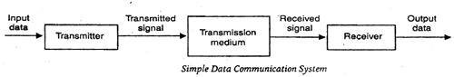

A data communication system may collect data from remote locations through data transmission circuits, and then outputs processed results to remote locations. Figure provides a broader view of data communication networks. The different data communication techniques which are presently in widespread use evolved gradually either to improve the data communication techniques already existing or to replace the same with better.options and features.
Then, there are data communication jargons to contend with such as baud rate, modems, routers, LAN, WAN, TCP/IP, ISDN, during the selection of communication systems. Hence, it becomes necessary to review and understand these terms and gradual development of data communication methods.
Components of data communication system are -
1. Message: It is the information or data to be communicated. It can consist of text, numbers, pictures, sound or video or any combination of these.
2. Sender: It is the device/computer that generates and sends that message.
3. Receiver: It is the device or computer that receives the message. The location of receiver computer is generally different from the sender computer. The distance between sender and receiver depends upon the types of network used in between.
4. Medium: It is the channel or physical path through which the message is carried from sender to the receiver. The medium can be wired like twisted pair wire, coaxial cable, fiber-optic cable or wireless like laser, radio waves, and microwaves.
5. Protocol: It is a set of rules that govern the communication between the devices. Both sender and receiver follow same protocols to communicate with each other.

Q.2. Explain network models
- OSI b) TCP / IP
Ans.
OSI Model
- OSI stands for Open System Interconnection is a reference model that describes how information from a software application in one computer moves through a physical medium to the software application in another computer.
- OSI consists of seven layers, and each layer performs a particular network function.
- OSI model was developed by the International Organization for Standardization (ISO) in 1984, and it is now considered as an architectural model for the inter-computer communications.
- OSI model divides the whole task into seven smaller and manageable tasks. Each layer is assigned a particular task.
- Each layer is self-contained, so that task assigned to each layer can be performed independently.

Characteristics of OSI

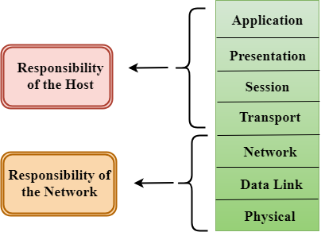
- The OSI model is divided into two layers: upper layers and lower layers.
- The upper layer of the OSI model mainly deals with the application related issues, and they are implemented only in the software. The application layer is closest to the end user. Both the end user and the application layer interact with the software applications. An upper layer refers to the layer just above another layer.
- The lower layer of the OSI model deals with the data transport issues. The data link layer and the physical layer are implemented in hardware and software. The physical layer is the lowest layer of the OSI model and is closest to the physical medium. The physical layer is mainly responsible for placing the information on the physical medium.

Functions of the OSI Layers
There are the seven OSI layers. Each layer has different functions. A list of seven layers are given below:
- Physical Layer
- Data-Link Layer
- Network Layer
- Transport Layer
- Session Layer
- Presentation Layer
- Application
- Cation Layer
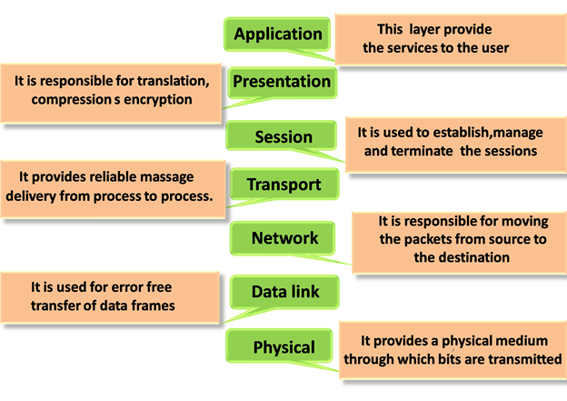

Physical layer
- The main functionality of the physical layer is to transmit the individual bits from one node to another node.
- It is the lowest layer of the OSI model.
- It establishes, maintains and deactivates the physical connection.
- It specifies the mechanical, electrical and procedural network interface specifications.

Data-Link Layer
- This layer is responsible for the error-free transfer of data frames.
- It defines the format of the data on the network.
- It provides a reliable and efficient communication between two or more devices.
- It is mainly responsible for the unique identification of each device that resides on a local network.
- It contains two sub-layers:
Logical Link Control Layer
    - It is responsible for transferring the packets to the Network layer of the receiver that is receiving.
    - It identifies the address of the network layer protocol from the header.
    - It also provides flow control.
Media Access Control Layer
    - A Media access control layer is a link between the Logical Link Control layer and the network's physical layer.
    - It is used for transferring the packets over the network.

Network Layer
- It is a layer 3 that manages device addressing, tracks the location of devices on the network.
- It determines the best path to move data from source to the destination based on the network conditions, the priority of service, and other factors.
- The Data link layer is responsible for routing and forwarding the packets.
- Routers are the layer 3 devices, they are specified in this layer and used to provide the routing services within an internet work.
- The protocols used to route the network traffic are known as Network layer protocols. Examples of protocols are IP and Ipv6.

Transport Layer
- The Transport layer is a Layer 4 ensures that messages are transmitted in the order in which they are sent and there is no duplication of data.
- The main responsibility of the transport layer is to transfer the data completely.
- It receives the data from the upper layer and converts them into smaller units known as segments.
- This layer can be termed as an end-to-end layer as it provides a point-to-point connection between source and destination to deliver the data reliably.

Session Layer
- It is a layer 3 in the OSI model.
- The Session layer is used to establish, maintain and synchronizes the interaction between communicating devices.

Presentation Layer
- A Presentation layer is mainly concerned with the syntax and semantics of the information exchanged between the two systems.
- It acts as a data translator for a network.
- This layer is a part of the operating system that converts the data from one presentation format to another format.
- The Presentation layer is also known as the syntax layer.

Application Layer
- An application layer serves as a window for users and application processes to access network service.
- It handles issues such as network transparency, resource allocation, etc.
- An application layer is not an application, but it performs the application layer functions.
- This layer provides the network services to the end-users.

TCP / IP Model

It stands for Transmission Control Protocol/Internet Protocol. The TCP/IP model is a concise version of the OSI model. It was developed before than OSI model.
TCP / IP helps to determine how a specific computer should be connected to the internet and how data should be transmitted between them.
It helps to create a virtual network when multiple computer networks are connected together. The purpose of TCP / IP model is to allow communication over large distance.

TCP / IP Model contain four layers -

Application Layer
- An application layer is the topmost layer in the TCP/IP model.
- It is responsible for handling high-level protocols, issues of representation.
- This layer allows the user to interact with the application.
- When one application layer protocol wants to communicate with another application layer, it forwards its data to the transport layer.
- There is an ambiguity occurs in the application layer. Every application cannot be placed inside the application layer except those who interact with the communication system. For example: text editor cannot be considered in application layer while web browser using HTTP protocol to interact with the network where HTTP protocol is an application layer protocol

Transport Layer
The transport layer is responsible for the reliability, flow control, and correction of data which is being sent over the network.
The two protocols used in the transport layer are User Datagram protocol and Transmission control protocol.
User Data gram Protocol (UDP)
  - It provides connection less service and end-to-end delivery of transmission.
  - It is an unreliable protocol as it discovers the errors but not specify the
  - error.
  - User Datagram Protocol discovers the error, and ICMP protocol reports the error to the sender that user datagram has been damaged.
  - UDP consists of the following fields:
Source port address: The source port address is the address of the application program that has created the message.
Destination port address: The destination port address is the address of the application program that receives the message.
Total length: It defines the total number of bytes of the user datagram in bytes.
Checksum: The checksum is a 16-bit field used in error detection.
  - UDP does not specify which packet is lost. UDP contains only checksum; it does not contain any ID of a data segment.
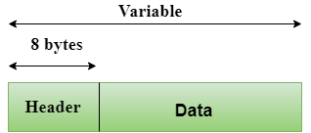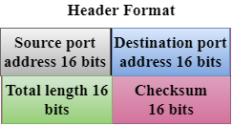

Transmission Control Protocol (TCP)
  - It provides a full transport layer services to applications.
  - It creates a virtual circuit between the sender and receiver, and it is active for the duration of the transmission.
  - TCP is a reliable protocol as it detects the error and retransmits the damaged frames. Therefore, it ensures all the segments must be received and acknowledged before the transmission is considered to be completed and a virtual circuit is discarded.
  - At the sending end, TCP divides the whole message into smaller units known as segment, and each segment contains a sequence number which is required for reordering the frames to form an original message.
  - At the receiving end, TCP collects all the segments and reorders them based on sequence numbers.

Q.3. What is digital and analog signal ? Explain all possible conversion.
Ans.
Digital Signal – A digital signal is a signal that represents data as a sequence of discrete values; at any given time it can only take on one of a finite number of values.
Analog Signal – An analog signal is any continuous signal for which the time varying feature of the signal is a representation of some other time varying quantity i.e., analogous to another time varying signal.
The following techniques can be used for Digital to Analog Conversion:
Amplitude Shift keying – Amplitude Shift Keying is a technique in which carrier signal is analog and data to be modulated is digital. The amplitude of analog carrier signal is modified to reflect binary data.
The binary signal when modulated gives a zero value when the binary data represents 0 while gives the carrier output when data is 1. The frequency and phase of the carrier signal remain constant.
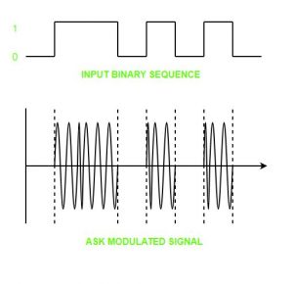

Advantages of amplitude shift Keying –
- It can be used to transmit digital data over optical fiber.
- The receiver and transmitter have a simple design which also makes it comparatively inexpensive.
- It uses lesser bandwidth as compared to FSK thus it offers high bandwidth efficiency.
Disadvantages of amplitude shift Keying –
- It is susceptible to noise interference and entire transmissions could be lost due to this.
- It has lower power efficiency.
2. Frequency Shift keying – In this modulation the frequency of analog carrier signal is modified to reflect binary data.
The output of a frequency shift keying modulated wave is high in frequency for a binary high input and is low in frequency for a binary low input. The amplitude and phase of the carrier signal remain constant.
Advantages of frequency shift Keying –
- Frequency shift keying modulated signal can help avoid the noise problems beset by ASK.
- It has lower chances of an error.
- It provides high signal to noise ratio.
- The transmitter and receiver implementations are simple for low data rate application.

Disadvantages of frequency shift Keying –
- It uses larger bandwidth as compared to ASK thus it offers less bandwidth efficiency.
- It has lower power efficiency.

3. Phase Shift keying – In this modulation the phase of the analog carrier signal is modified to reflect binary data.The amplitude and frequency of the carrier signal remains constant.
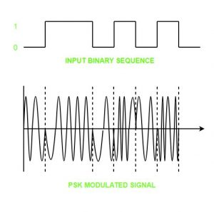

Q.4. What is multiplexing ? Explain all different types of multiplexers
Ans.
Multiplexing is the process of combining multiple signals into one signal, over a shared medium. If analog signals are multiplexed, it is Analog Multiplexing and if digital signals are multiplexed, that process is Digital Multiplexing.
The process of multiplexing divides a communication channel into several number of logical channels, allotting each one for a different message signal or a data stream to be transferred. The device that does multiplexing can be simply called as a MUX while the one that reverses the process which is demultiplexing, is called as DEMUX.

Advantages of Multiplexing:
- More than one signal can be sent over a single medium.
- The bandwidth of a medium can be utilized effectively.

Types of Multiplexers
There are mainly two types of multiplexers, namely analog and digital. They are further divided into FDM, WDM, and TDM.
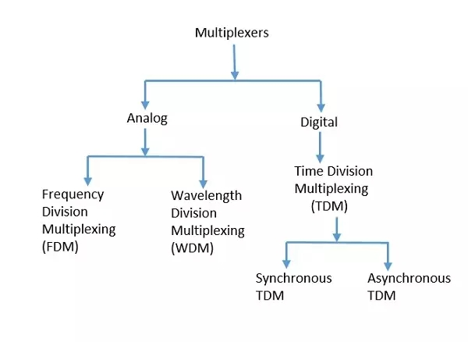

Analog Multiplexing
The analog multiplexing techniques involve signals which are analog in nature. The analog signals are multiplexed according to their frequency (FDM) or wavelength (WDM).
Frequency Division Multiplexing (FDM)
In analog multiplexing, the most used technique is Frequency Division Multiplexing FDM. This technique uses various frequencies to combine streams of data, for sending them on a communication medium, as a single signal.
Example: A traditional television transmitter, which sends a number of channels through a single cable, uses FDM.
Wavelength Division Multiplexing (WDM)
Wavelength Division Multiplexing is an analog technique, in which many data streams of different wavelengths are transmitted in the light spectrum. If the wavelength increases, the frequency of the signal decreases.
Example: Optical fibre Communications use the WDM technique, to merge different wavelengths into a single light for the communication.

Digital Multiplexing
The term digital represents the discrete bits of information. Hence the available data is in the form of frames or packets, which are discrete.
Time Division Multiplexing (TDM)
In TDM, the time frame is divided into slots. This technique is used to transmit a signal over a single communication channel, with allotting one slot for each message. Of all the types of TDM, the main ones are Synchronous and Asynchronous TDM.
Synchronous TDM
In Synchronous TDM, the input is connected to a frame. If there are ‘n’ number of connections, then the frame is divided into ‘n’ time slots. One slot is allocated for each input line. In this technique, the sampling rate is common to all signals and hence same clock input is given. The mux allocates the same slot to each device at all times.
Asynchronous TDM
In Asynchronous TDM, the sampling rate is different for each of the signals and the clock signal is also not in common. If the allotted device, for a time-slot, transmits nothing and sits idle, then that slot is allotted to another device, unlike synchronous.

Q.5. Define the switching technique and its types ?
Ans.
In large networks, there may be more than one paths for transmitting data from sender to receiver. Selecting a path that data must take out of the available options is called switching. Switching technique is used to connect the systems for making one-to-one communication.
There are two popular switching techniques – circuit switching and packet switching.

Circuit Switching
When a dedicated path is established for data transmission between sender and receiver, it is called circuit switching. When any network node wants to send data, be it audio, video, text or any other type of information, a call request signal is sent to the receiver and acknowledged back to ensure availability of dedicated path. This dedicated path is then used to send data. ARPANET used circuit switching for communication over the network.

Advantages of Circuit Switching
Circuit switching provides these advantages over other switching techniques −
- Once path is set up, the only delay is in data transmission speed
- No problem of congestion or garbled message

Disadvantages of Circuit Switching
Circuit switching has its disadvantages too −
- Long set up time is required
- A request token must travel to the receiver and then acknowledged before any transmission can happen
- Line may be held up for a long time

Packet Switching
As we discussed, the major problem with circuit switching is that it needs a dedicated line for transmission. In packet switching, data is broken down into small packets with each packet having source and destination addresses, travelling from one router to the next router.

Q.6. Explain error detection and correction method ?
Ans.
Error is a condition when the output information does not match with the input information. During transmission, digital signals suffer from noise that can introduce errors in the binary bits travelling from one system to other. That means a 0 bit may change to 1 or a 1 bit may change to 0.
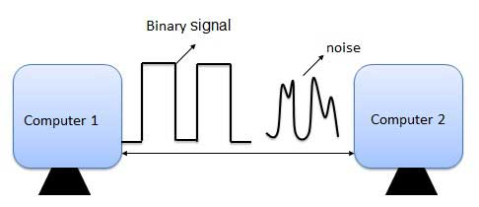

Error-Detecting codes
Whenever a message is transmitted, it may get scrambled by noise or data may get corrupted. To avoid this, we use error-detecting codes which are additional data added to a given digital message to help us detect if an error occurred during transmission of the message. A simple example of error-detecting code is parity check.

Error-Correcting codes
Along with error-detecting code, we can also pass some data to figure out the original message from the corrupt message that we received. This type of code is called an error-correcting code. Error-correcting codes also deploy the same strategy as error-detecting codes but additionally, such codes also detect the exact location of the corrupt bit.
In error-correcting codes, parity check has a simple way to detect errors along with a sophisticated mechanism to determine the corrupt bit location. Once the corrupt bit is located, its value is reverted (from 0 to 1 or 1 to 0) to get the original message.

Detect and Correct Errors?
  - To detect and correct the errors, additional bits are added to the data bits at the time of transmission.
  - The additional bits are called parity bits. They allow detection or correction of the errors.
  - The data bits along with the parity bits form a code word.

Parity Checking of Error Detection
It is the simplest technique for detecting and correcting errors. The MSB of an 8-bits word is used as the parity bit and the remaining 7 bits are used as data or message bits. The parity of 8-bits transmitted word can be either even parity or odd parity.
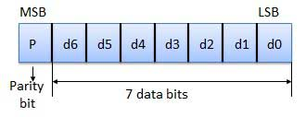
Even parity -- Even parity means the number of 1's in the given word including the parity bit should be even (2,4,6,....).
Odd parity -- Odd parity means the number of 1's in the given word including the parity bit should be odd (1,3,5,....).

Use of Parity Bit
The parity bit can be set to 0 and 1 depending on the type of the parity required.
- For even parity, this bit is set to 1 or 0 such that the no. of "1 bits" in the entire word is even. Shown in fig. (a).
- For odd parity, this bit is set to 1 or 0 such that the no. of "1 bits" in the entire word is odd. Shown in fig. (b).
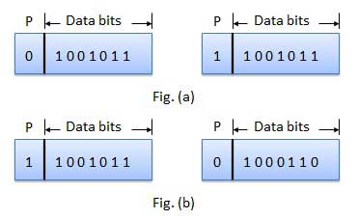

How Does Error Detection Take Place?
Parity checking at the receiver can detect the presence of an error if the parity of the receiver signal is different from the expected parity. That means, if it is known that the parity of the transmitted signal is always going to be "even" and if the received signal has an odd parity, then the receiver can conclude that the received signal is not correct. If an error is detected, then the receiver will ignore the received byte and request for retransmission of the same byte to the transmitter.
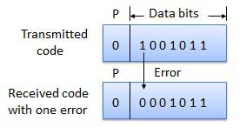

Assignment II
M.K.H.S. Gujarati Girls College, Indore
Name : Aayushi Sethi
Class : BCA V sem
Subject : Computer Networks

Q.1. What is router ? Explain how it works.
Ans. A router is a device that communicates between the internet and the devices in your home that connect to the internet. As its name implies, it “routes” traffic between the devices and the internet.
Router connect computers and other devices to the Internet. A router acts as a dispatcher, choosing the best route for your information to travel. It connects your business to the world, protects information from security threats, and can even decide which computers get priority over others.
A typical home has a range of internet-connected devices — personal computers, tablets, smartphones, printers, thermostats, smart TVs, and more. With your router, these devices form a network. A router directs incoming and outgoing internet traffic on that network in the fastest and most efficient way.
The information traveling on your home network could be an email, a movie, or a live feed from your baby cam, each of which takes up varying amounts of bandwidth. Making sure that information is delivered quickly and correctly is a big task — and getting bigger. As you add more and more devices — think Internet of Things — you ask your router to do more.

Q.2. What is frequency reuse.
Ans. Technique for using a specified range of frequencies more than once in the same radio system so that the total capacity of the system is increased without increasing its allocated bandwidth. Frequency reuse schemes require sufficient isolation among the signals that use the same frequencies so that mutual interference among them is controlled at an acceptable level. For satellites, frequency reuse can be achieved by using orthogonal polarization states for transmission and/or by using satellite antenna (spot) beams that serve separate, non-overlapping geographic regions.

Frequency Reuse is the scheme in which allocation and reuse of channels throughout a coverage region is done. Each cellular base station is allocated a group of radio channels or Frequency sub-bands to be used within a small geographic area known as a cell. The shape of the cell is Hexagonal. The process of selecting and allocating the frequency sub-bands for all of the cellular base station within a system is called Frequency reuse or Frequency Planning.
Silent Features of using Frequency Reuse:
- Frequency reuse improve the spectral efficiency and signal Quality (QoS).
- Frequency reuse classical scheme proposed for GSM systems offers a protection against interference.
- The number of times a frequency can be reused is depend on the tolerance capacity of the radio channel from the nearby transmitter that is using the same frequencies.
- In Frequency Reuse scheme, total bandwidth is divided into different sub-bands that are used by cells
- . Frequency reuse scheme allow WiMax system operators to reuse the same frequencies at different cell sites.
- 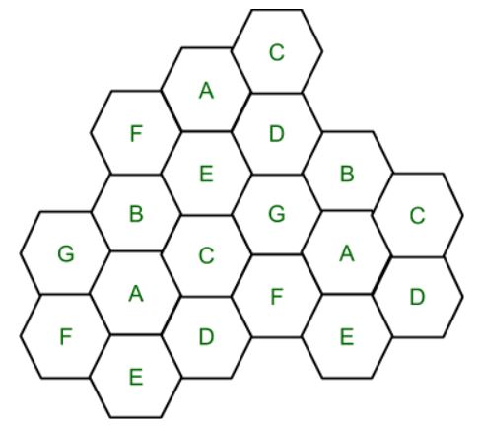

Q.3. What is IPV4 and IPV6. Differentiate both.
Ans.
IPV4 and IPv6 are internet protocol version 4 and internet protocol version 6, IP version 6 is the new version of Internet Protocol, which is way better than IP version 4 in terms of complexity and efficiency.
Difference Between IPv4 and IPv6:
IPV4 | IPV6
IPv4 has 32-bit address length | IPv6 has 128-bit address length
It Supports Manual and DHCP address configuration | It supports Auto and renumbering address configuration
In IPv4 end to end connection integrity is Unachievable | In IPv6 end to end connection integrity is Achievable
It can generate 4.29×109 address space | Address space of IPv6 is quite large it can produce 3.4×1038 address space
Security feature is dependent on application | IPSEC is inbuilt security feature in the IPv6 protocol
Address representation of IPv4 is in decimal | Address Representation of IPv6 is in hexadecimal
Fragmentation performed by Sender and forwarding routers | In IPv6 fragmentation performed only by sender
In IPv4 Packet flow identification is not available | In IPv6 packetflow identification are Available and uses flow label field in the header
In IPv4 checksumfield is available | In IPv6 checksumfield is not available
It has broadcast Message Transmission Scheme | In IPv6 multicast and any cast message transmission scheme is available
In IPv4 Encryption and Authentication facility not provided | In IPv6 Encryption and Authentication are provided
IPv4 has header of 20-60 bytes | IPv6 has header of 40 bytes fixed

Q.5. What is error detection and correction ? How to check it on parity checker ?
Ans. Error is a condition when the output information does not match with the input information. During transmission, digital signals suffer from noise that can introduce errors in the binary bits travelling from one system to other. That means a 0 bit may change to 1 or a 1 bit may change to 0.

Error-Detecting codes
Whenever a message is transmitted, it may get scrambled by noise or data may get corrupted. To avoid this, we use error-detecting codes which are additional data added to a given digital message to help us detect if an error occurred during transmission of the message. A simple example of error-detecting code is parity check.

Error-Correcting codes
Along with error-detecting code, we can also pass some data to figure out the original message from the corrupt message that we received. This type of code is called an error-correcting code. Error-correcting codes also deploy the same strategy as error-detecting codes but additionally, such codes also detect the exact location of the corrupt bit.
In error-correcting codes, parity check has a simple way to detect errors along with a sophisticated mechanism to determine the corrupt bit location. Once the corrupt bit is located, its value is reverted (from 0 to 1 or 1 to 0) to get the original message.

Detect and Correct Errors?
  - To detect and correct the errors, additional bits are added to the data bits at the time of transmission.
  - The additional bits are called parity bits. They allow detection or correction of the errors.
  - The data bits along with the parity bits form a code word.

Parity Checking of Error Detection
It is the simplest technique for detecting and correcting errors. The MSB of an 8-bits word is used as the parity bit and the remaining 7 bits are used as data or message bits. The parity of 8-bits transmitted word can be either even parity or odd parity.

Q.6. Explain UDP network security ?
Ans. User Datagram Protocol (UDP) is a Transport Layer protocol. UDP is a part of Internet Protocol suite, referred as UDP/IP suite. Unlike TCP, it is unreliable and connectionless protocol. So, there is no need to establish connection prior to data transfer.
Though Transmission Control Protocol (TCP) is the dominant transport layer protocol used with most of Internet services; provides assured delivery, reliability and much more but all these services cost us with additional overhead and latency. Here, UDP comes into picture. For the realtime services like computer gaming, voice or video communication, live conferences; we need UDP. Since high performance is needed, UDP permits packets to be dropped instead of processing delayed packets. There is no error checking in UDP, so it also save bandwidth.
UDP Header –
UDP header is 8-bytes fixed and simple header, while for TCP it may vary from 20 bytes to 60 bytes. First 8 Bytes contains all necessary header information and remaining part consist of data. UDP port number fields are each 16 bits long, therefore range for port numbers defined from 0 to 65535; port number 0 is reserved. Port numbers help to distinguish different user requests or process.

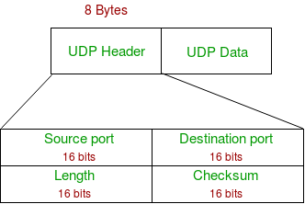

- Source Port : Source Port is 2 Byte long field used to identify port number of source.
- Destination Port : It is 2 Byte long field, used to identify the port of destined packet.
- Length : Length is the length of UDP including header and the data. It is 16-bits field.
- Checksum : Checksum is 2 Bytes long field. It is the 16-bit one’s complement of the one’s complement sum of the UDP header, pseudo header of information from the IP header and the data, padded with zero octets at the end (if necessary) to make a multiple of two octets.
Notes – Unlike TCP, Checksum calculation is not mandatory in UDP. No Error control or flow control is provided by UDP. Hence UDP depends on IP and ICMP for error reporting.
Applications of UDP:
- Used for simple request response communication when size of data is less and hence there Is lesser concern about flow and error control.
- It is suitable protocol for multicasting as UDP supports packet switching.
- UDP is used for some routing update protocols like RIP(Routing Information Protocol).
- Normally used for real time applications which can not tolerate uneven delays between sections of a received message.
- Following implementations uses UDP as a transport layer protocol:
  - NTP (Network Time Protocol)
  - DNS (Domain Name Service)
  - BOOTP, DHCP.
  - NNP (Network News Protocol)
  - Quote of the day protocol
  - TFTP, RTSP, RIP.
- Application layer can do some of the tasks through UDP-
  - Trace Route
  - Record Route
  - Time stamp
- UDP takes datagram from Network Layer, attach its header and send it to the user. So, it works fast.
- Actually UDP is null protocol if you remove checksum field.
  - Reduce the requirement of computer resources.
  - When using the Multicast or Broadcast to transfer.
  - The transmission of Real-time packets, mainly in multimedia applications.

